Numerical Methods
Project C No. 5

JULIA CZMUT
300168

Problem 1.

1. 1. Description of the problem

In this problem, for the following experimental measurements:

x _{i} | y _{i}
-5 | 17.0255
-4 | 12.5361
-3 | 6.5452
-2 | 2.6381
-1 | 0.8754
0 | -0.5799
1 | -0.5217
2 | 0.5796
3 | 4.8296
4 | 11.6793
5 | 18.5855

we are to determine a polynomial function y = f(x) that best fits the experimental data by using the least-squares approximation. Polynomials of various degrees are tested. For solving the least-squares problem, a system of normal equations with QR factorization of a matrix A is used. For each solution we define: the error (Euclidean norm of the vector of residuum) and the condition number of the Gram’s matrix. The results are compared with respect to the solutions’ errors.

1. 2. Theoretical background

Least-squares problem

It can be treated as a problem of solving a set of m linear equations with n unknowns, where n > m (an overdetermined system of equations). Its solution may not be unique, therefore a minimal norm of the solution is usually required, to make it unique.

In cases where the matrix composed of the set of equations may be ill-conditioned, it is recommended to use the QR factorization to obtain the solution. It is important to note that the narrow, not the normalized QR factorization can be applied to a LLSP. The system of equations obtained from QR factorization needs less computations than the normal system of linear equations, because it creates a triangular matrix.

Discrete least-squares approximation

The main idea of the approximation is to find values of parameters a₀, a₁, … , a_{n} defining the approximating function:

We find those parameters by a set of linear equations called the set of normal equations. Its matrix is known as the Gram’s matrix.

If we define the scalar product, the normal equations can be written simply:

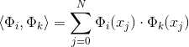

The set of normal equations then looks as follows:

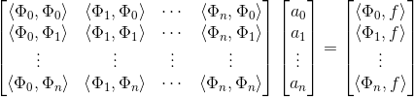

The least-squares error is defined by:

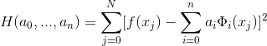

Polynomial approximation

Polynomials are often used as approximating functions.
Usually, the order n of the approximating polynomial is much lower than the number of data points given N, so

Natural polynomial basis, also called the power basis is defined by:

Other form:

The system of normal equations can be presented as follows:

Where G is the Gram’s matrix composed of elements g_{ik,}
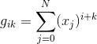

elements of a are the unknown parameters a₀, a₁, …, a_{n}

and ϱ is the vector with elements defined as:
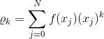

1. 3. Algorithm (steps performed to solve the problem)

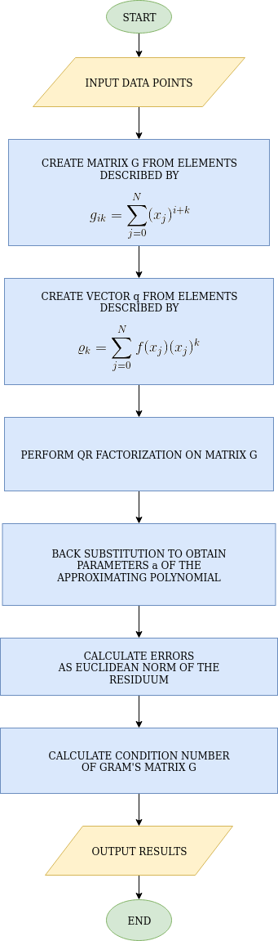

1. 4. Results

Graphs of approximating polynomials of various orders
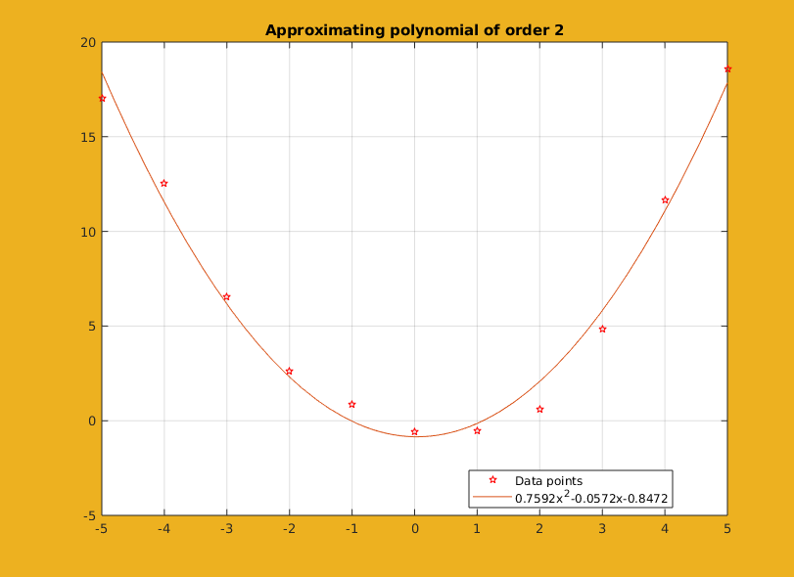
error: 1.0516e-12

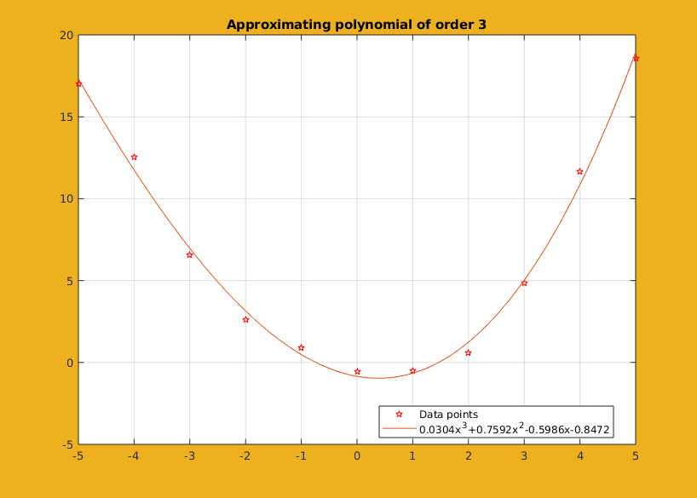
error: 1.1090e-12

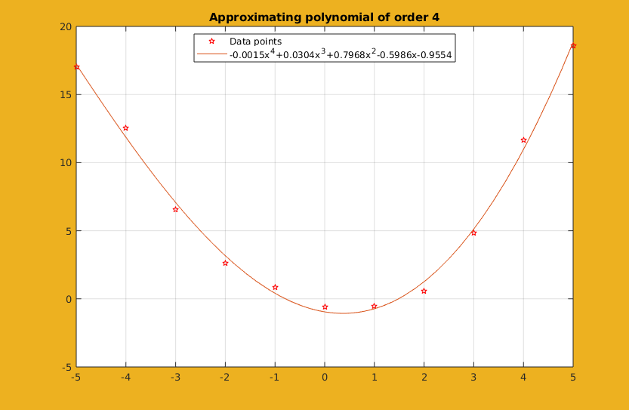
error: 3.3826e-09

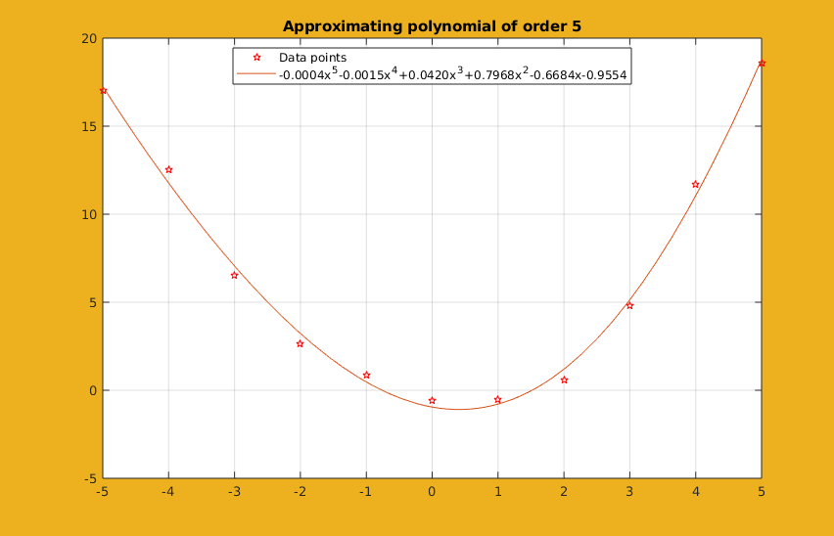
error: 7.3569e-09

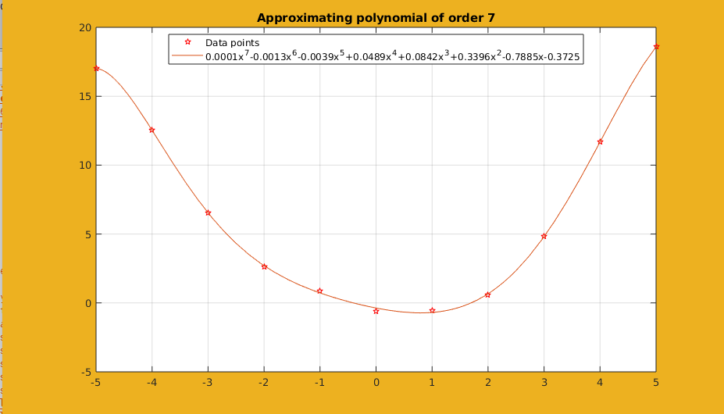
error: 3.0701e-05

Above approximations combined on one graph

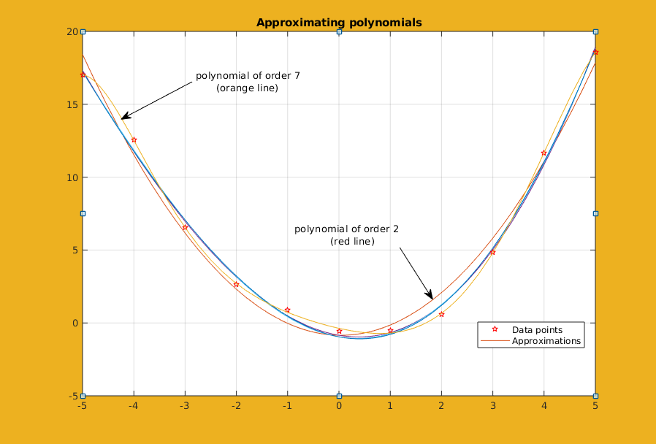

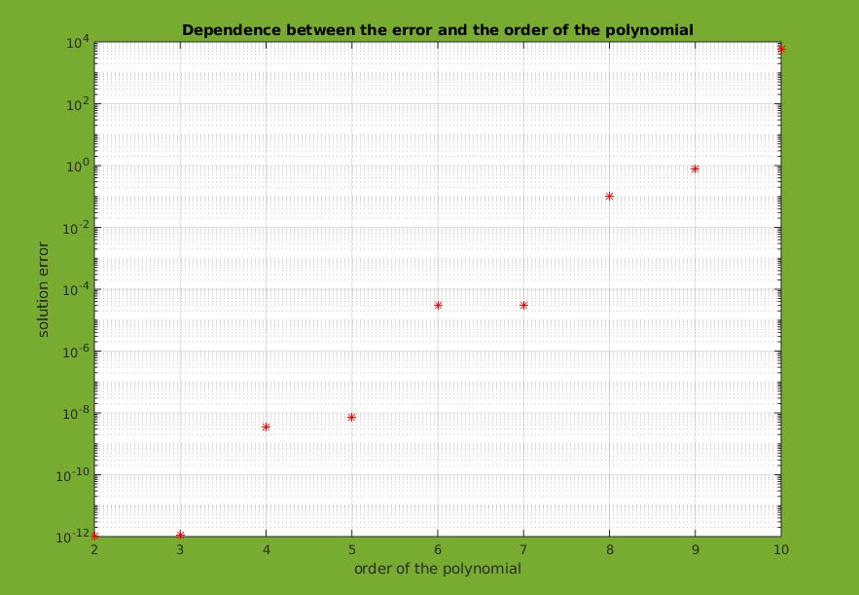

ORDER OF THE POLYNOMIAL | ERROR | CONDITION NUMBER OF THE GRAM’S MATRIX
2 | 1.0516e-12 | 408.7796
3 | 1.1090e-12 | 8.5584e+03
4 | 3.3826e-09 | 3.1798e+05
5 | 7.3569e-09 | 7.4675e+06
6 | 2.9956e-05 | 2.8316e+08
7 | 3.0701e-05 | 7.6462e+09
8 | 0.1016 | 3.3055e+11
9 | 0.7989 | 1.5167e+13
10 | 5.7204e+03 | 9.2930e+14

1. 5. Comments and conclusions

About graphs of approximations

Polynomial of order 2 is not the best fit for approximating the experimental data. The distance between some points and the plot is in some cases quite big. In this aspect, polynomial of order 7 seems to be without a doubt a better fit for approximating the given data. It covers the points more accurately.
However, the errors defined as the Euclidean norm of the vector of residuum grow with the increasing order of the polynomials. The reason for it may be that the bigger the order, the bigger the matrices become. Moreover, the values in the matrices are small fractions and operations on them cause accumulation of errors.

The Gram’s matrix G for the systems of normal equations obtained for the approximating polynomials based on power basis is of Hilbert type and quickly becomes ill-conditioned with an increase of the order of the polynomial. It is well visible in the table which provides the condition numbers for cases with polynomials of orders from 2 to 10. The conditions numbers grow very rapidly.

When the basis functions are orthogonal, the Gram’s matrix is a diagonal one and we obtain a well-conditioned set of equations.
Therefore it is good to use QR factorization which orthogonalizes the polynomials in the basis.

Errors proved to indeed be small, as seen in the same table, except for higher order polynomials, specifically of order 8 and higher – then they grow rapidly. Those dependencies are also shown on the graph above the table.

Problem 2.

2. 1. Description of the problem

In this problem, we have equations describing the motion of a point.

We are to determine the trajectory of the motion on the interval [0, 15] for the following initial conditions:

It is to be done in two ways:

a) Runge-Kutta method of 4th order (RK4) and Adams PC (P₅EC₅E) – each method a few times, with different constant step-sizes until an “optimal” constant step size is found, i.e., when its decrease does not influence the solution significantly, but its increase does.

b) Runge-Kutta method of 4th order (RK4) with a variable step size automatically adjusted by the algorithm, making error estimation according to the step-doubling rule.

2. 2. a) Theoretical background

Ordinary differential equations

They are often used for mathematical modeling and describing dynamic systems, like in our task: motion of a point. Real-life problems with differential equations are usually nonlinear and the only way for finding the solutions are numerical methods.

If a function f :
- is continuous over the set
- satisfies the Lipschitz condition with respect to y
(function does not grow too fast)

then, for any initial condition y_{a} there is a unique and continuously differentiable function y(x), such that

There are single-step methods and multi-step methods.
To put it simply, in a single-step method, we check what happens in a point and around it, but we forget about this information in next iterations.
On the other hand, in a multi-step method, we also care about previous iterations.

All those methods are difference methods, which means that the approximate values of the solution functions are calculated at subsequent discrete points x_{n} .
The difference between those points is h_{n} - step size, which may be constant or varying.

Convergence of the method

A numerical method for a system of differential equations is convergent, if for any system having a unique solution y(x), and for the step length h_{n} converging to zero for all steps, the following holds:

y(x_{n}; h_{n}) denotes the approximate solution found by the method.

The Runge-Kutta methods

Family of RK methods are described by
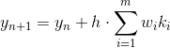
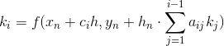
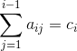
To perform a single step of the method, the values of right-hand sides of the equations must be calculated m times. That is why this method is an m-stage one.

Methods with m=4 and of order p=4 are most important because of their good properties.

The Runge-Kutta method of order 4
(RK4, “classical”)

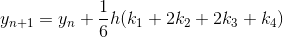
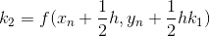
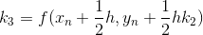
Step-size selection

Choosing the right step-size is a fundamental problem of solving differential equations, because:

- if the step h_{n} is smaller, then the approximation error of the method is smaller, BUT
- if the step is smaller, then also the number of steps needed to find a solution increases and therefore, numerical roundoff errors increase

Taking this into consideration, the steps should not be too small – not much smaller than necessary to obtain desired accuracy.

Multistep methods

A single iteration of a multistep method with a constant step-size h can be defined by

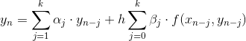
A multistep method is explicit if β₀ = 0.
Then, the value y_{n} depends explicitly on values of the solution and its derivative at previously calculated points only.

On the other hand, a multistep method is implicit if β₀ ≠ 0.
It means that the value y_{n} depends not only on previously calculated points, but also on current point. Therefore, in order to calculate y_{n}, it is necessary to first perform a starting procedure and evaluate values at current point using another method, for example RK4.

Predictor-corrector methods

The perfect multistep method would have:

1. a high order and a small error constant
2. a large set of the absolute stability (characteristic polynomial has all roots within the unit circle)
3. a small number of arithmetic operations performed during one iteration.

Explicit methods fulfill the last property and implicit fulfill the first two. Therefore, the most efficient way to use multistep methods is by combining both types in a predictor-corrector (PC) structure.

Algorithm used in this task is Adams PC (P₅EC₅E)

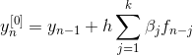
P - prediction

E – evaluation
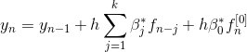
C – correction

E - evaluation

2. 3. a) Results for Runge-Kutta method of order 4

1. x1 vs x2 solution curves

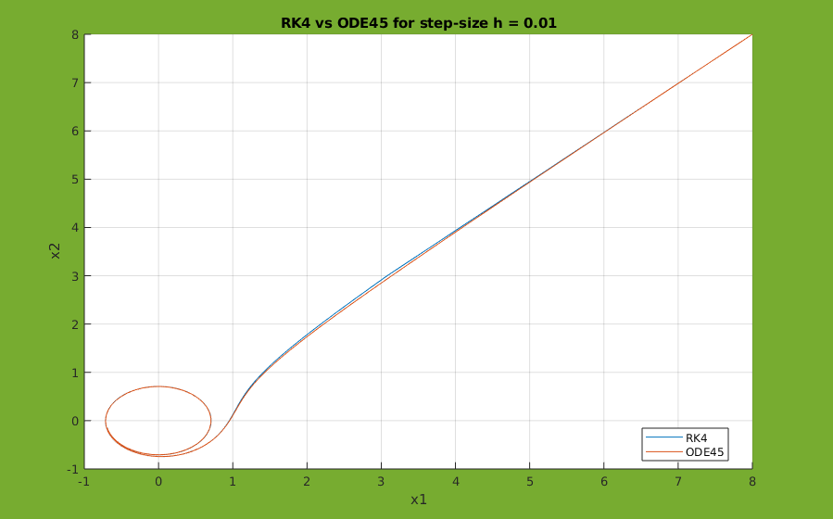
↑ hypothesis: optimal step-size

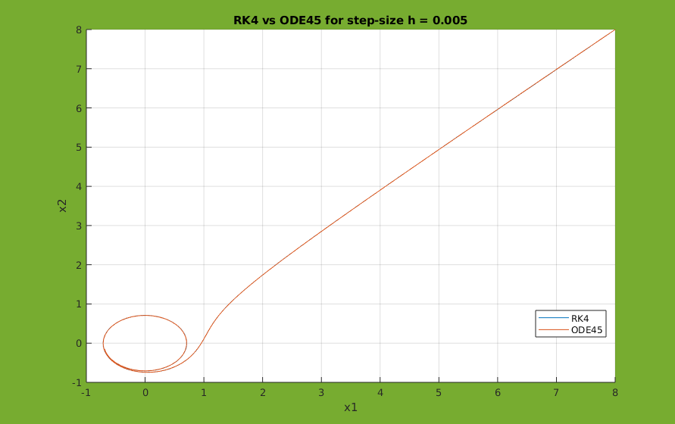
↑ no significant influence on the solution when step-size is decreased

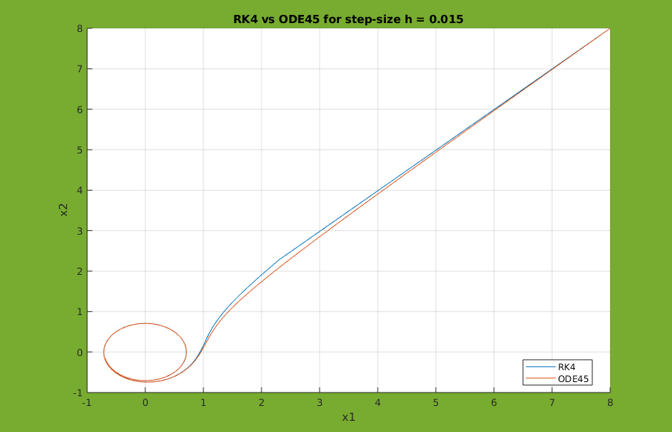
↑ visible influence on the solution when step-size is increased

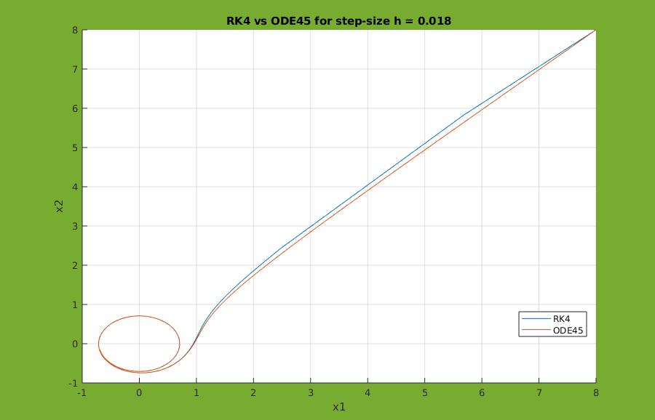
↑ even more visible influence on the solution when step-size is increased

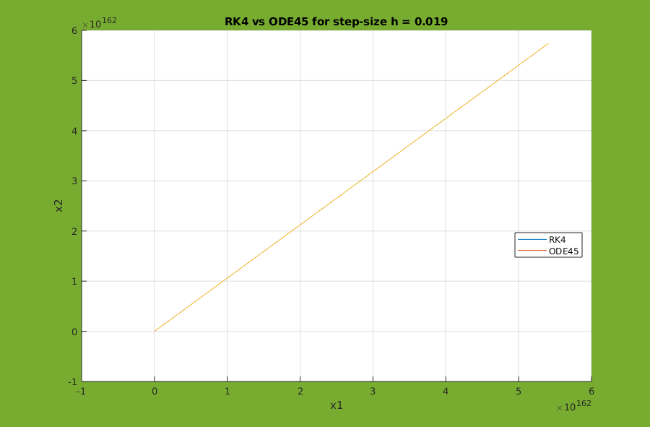
↑ step-size is too big

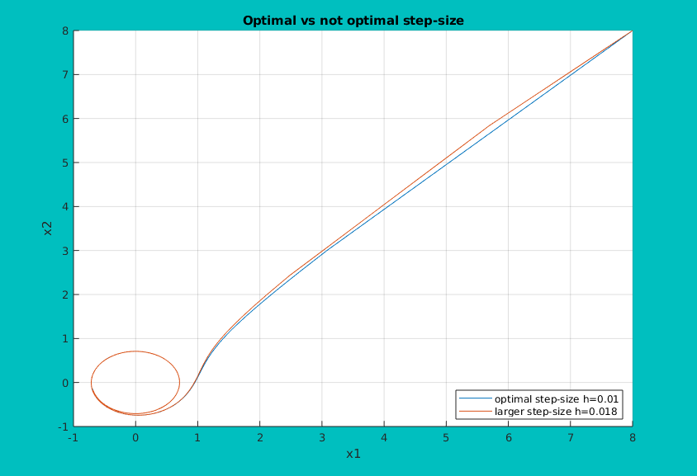
2. Comparison of solution curves for optimal and larger step-size

3. Time dependent plots

x₁(t)
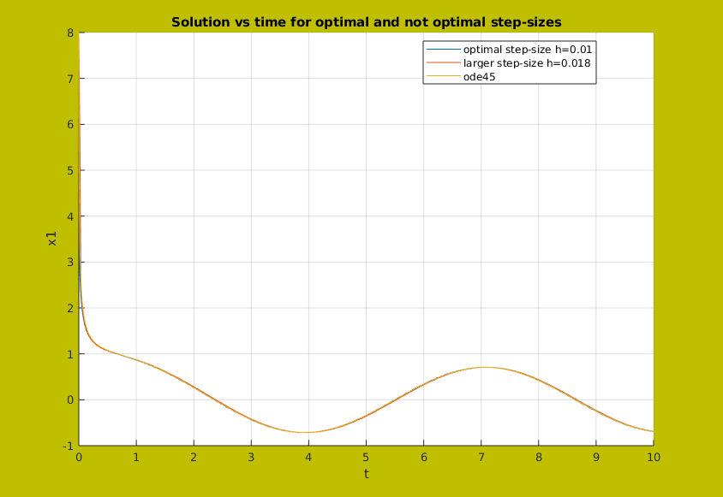
x₂(t)
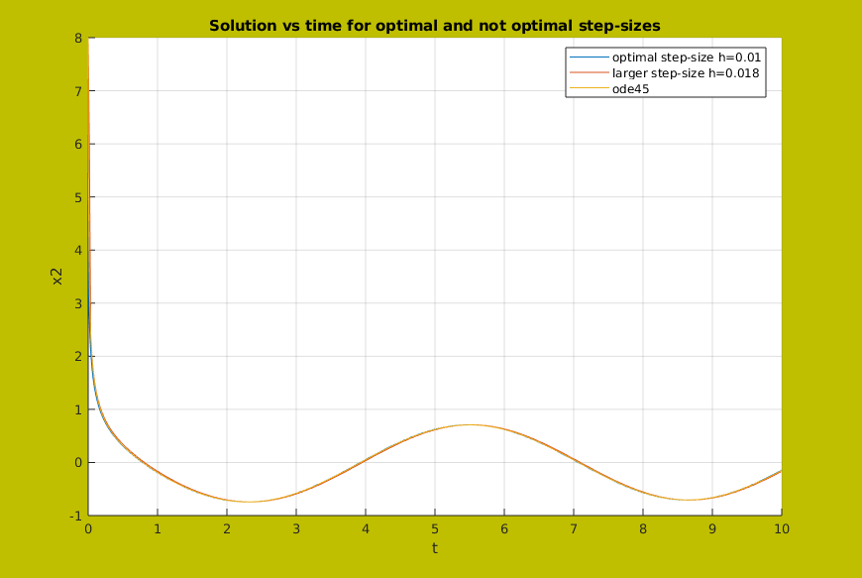

Results for Adams PC method (P₅EC₅E)

1. x1 vs x2 solution curves
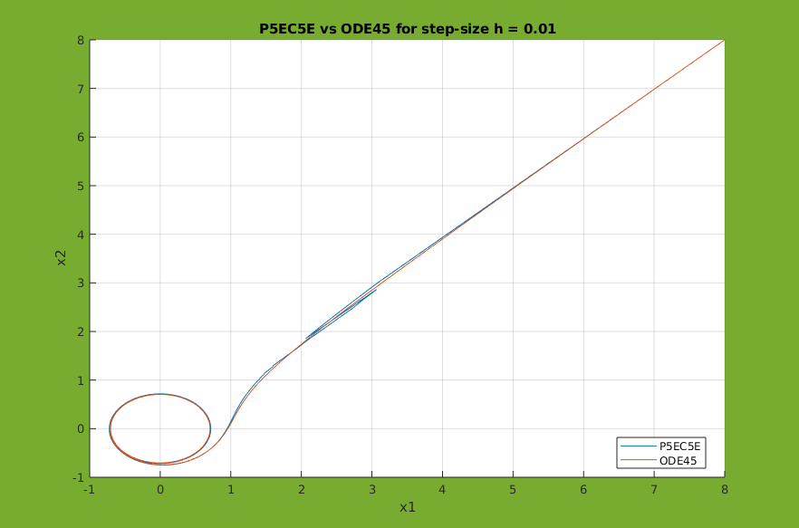

↑ hypothesis: optimal step-size

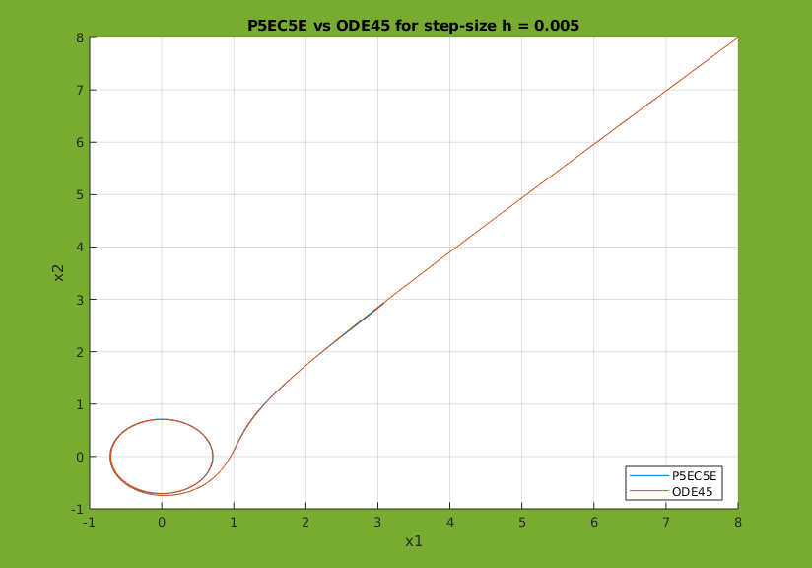
↑ no significant influence on the solution when step-size is decreased
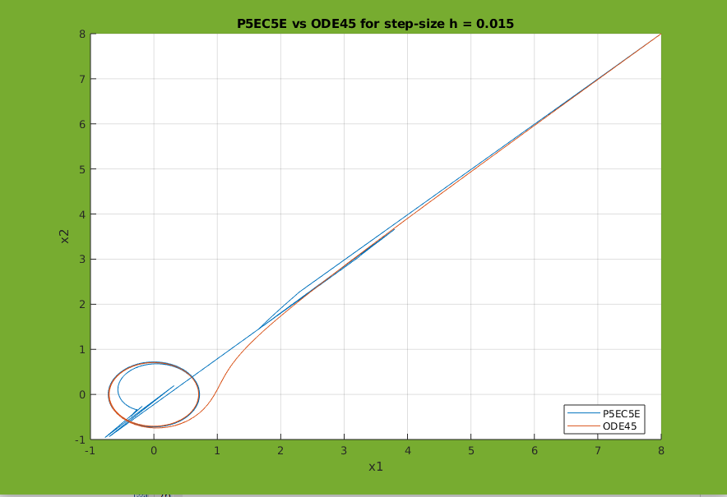
↑ visible influence on the solution when step-size is increased
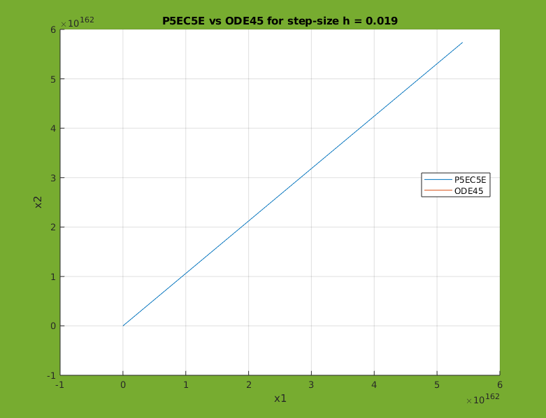
↑ step-size is too big

2. Comparison of solution curves for optimal and larger step-size

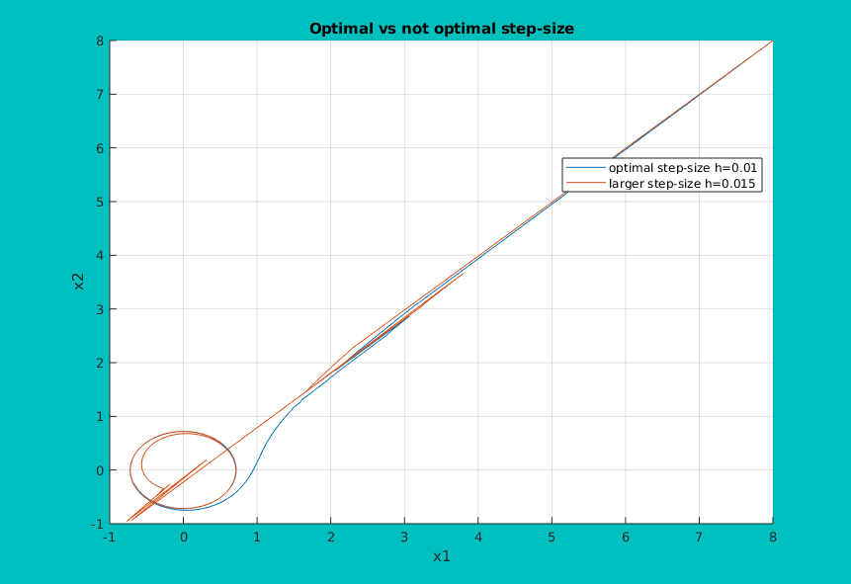

3. Time dependent plots

x₁(t)
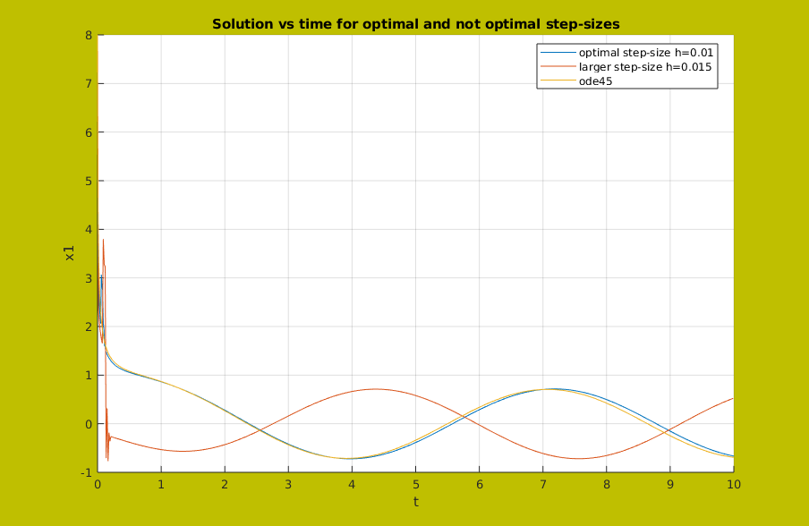

x₂(t)
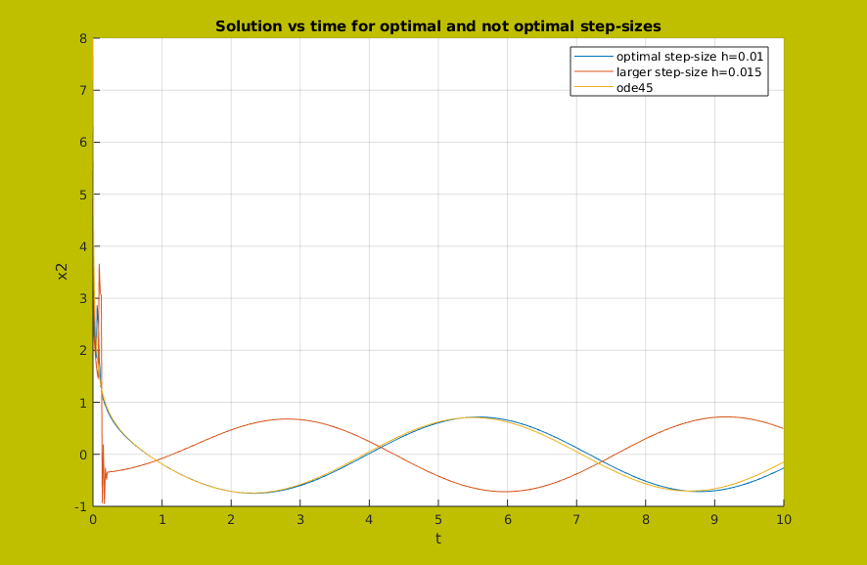

2. 4. a) Comments and conclusions

The main problem with choosing a constant step-size is that while decreasing the step causes decreasing of the approximation error, decreasing it too much induces more arithmetic operations and therefore, more roundoff errors.
In this problem, the program proved to be very sensitive to the change of the step-size.
While step-size h=0.01 was the optimal one, with a step only 0.009 bigger, the solution would not be found at all in both methods.

In case of Runge-Kutta method, the biggest value of h, for which the method worked and there was a visible difference in the solution, was 0.018 (for 0.019 there was no solution). However, even with this step-size, our found solution did not differ from the solution generated by an ODE solver as much as it did in Adams PC method.
Due to this fact, the larger step-size acted almost as good as the more optimal one in RK4 – 0.01.
It is most visible in the time dependent graphs. All three plots are almost identical.

That was not the case with Adams PC method. The solution differed significantly from the one obtained by ode45 even with step-size equal to 0.015. Therefore, in time dependent graphs we see a big distinction between the correct solution and a solution with a poorer choice of step-size.

Based on these observations, we can conclude that even though both RK4 and Adams PC methods are sensitive to step-size changes, Adams PC method is much more sensitive in this aspect than Runge-Kutta method.

2. 2. b) Theoretical background

RK4 is the method used in this task, it was described in theoretical background for task a).

In task 2.a) the constant step-size was adjusted by the user. There is an obvious problem with this approach – the problem must be solved many times with different step-sizes to find the best one.

Better approach would be that the variable step-size was adjusted automatically by the method itself, at each step. In order to perform an automatic step-size adjustment, we need to provide the method with an estimate of the approximation error at each step.

Error estimation – The step-doubling approach

The main idea of this approach is that for every step h, two additional steps of the size 0.5h are performed in parallel.

To elaborate, we need to denote:

- a new point obtained using a step-size h

- a new point obtained using two consecutive steps of the size 0.5h

- the approximation error after the single step h

- the summed approximation errors after the two smaller steps

For simplification, we also assume that the approximation error for all smaller steps is the same.

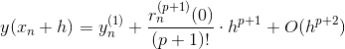
After a single step:

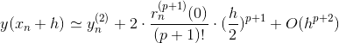
After a double step:

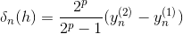
Error estimate for a single step h:

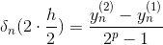
Error estimate for two smaller steps 0.5h:

Error for a single step is 2^{p} times bigger than for a double step.

Correction of the step-sizes

A general formula for the main part of the approximation error is:

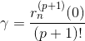
If we change the step-size from h to αh and assume a tolerance ε:

Then the coefficient α for the step-size correction is:

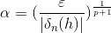
The above formula is correct for the step-size h, as well as for the step-size 0.5h.

Important thing to take into consideration is the lack of accuracy in the error estimation. It is dealt with by using a safety factor s:

Generally, s should be smaller than 1 and specifically for RK4 it is around 0.9.

The tolerance parameters should be defined as follows:

- relative tolerance

- absolute tolerance

Algorithm for the RK4 method automatic step-size adjustment

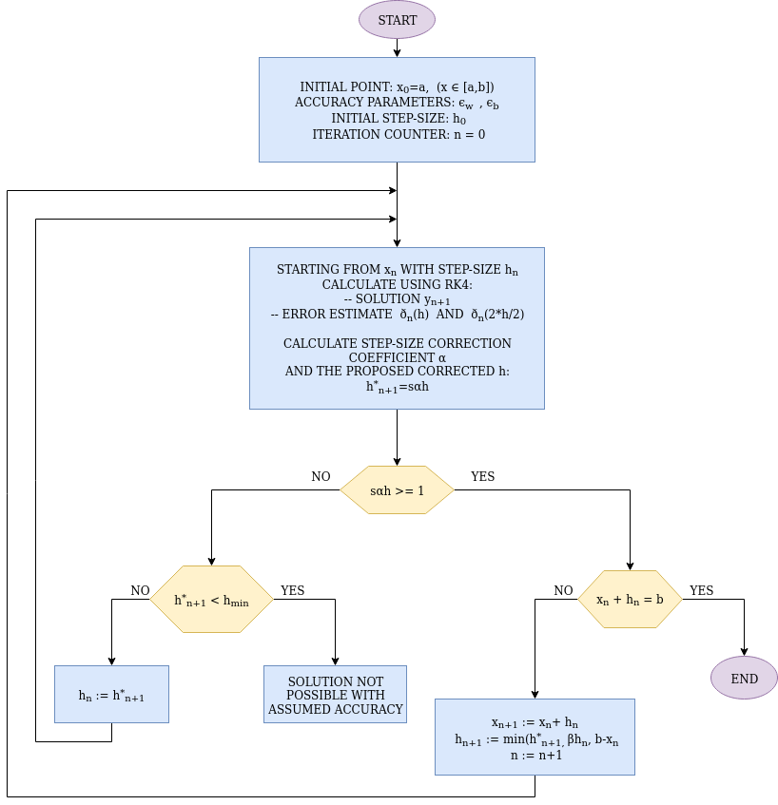

2. 3. b) Results for Runge-Kutta method of order 4 with automatic step-size adjustment

